27.55: The direction of 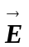 is horizontal and perpendicular to 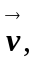 as shown in the sketch:
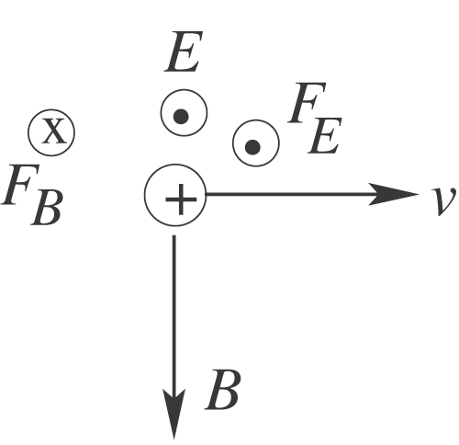
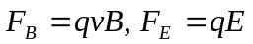
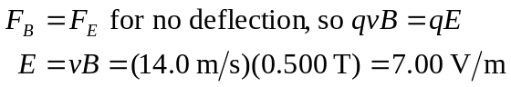
We ignored the gravity force. If the target is 5.0 m from the rifle, it takes the bullet 0.36 s to reach the target and during this time the bullet moves downward 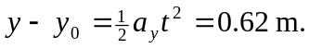 The magnetic and electric forces we considered are horizontal. A vertical electric field of 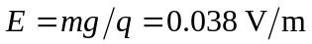 would be required to cancel the gravity force. Air resistance has also been neglected.

